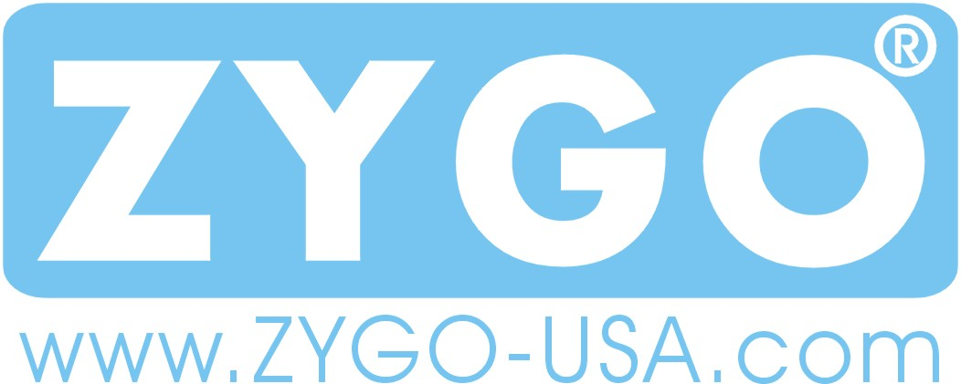

Medical Information Consent Form
By signing this form, you are granting consent to ZYGO-USA to use and disclose your protected health information for the purposes of treatment, payment and health care operations.
By signing this form you are acknowledging that ZYGO-USA has provided you with a copy of Our Notice of Privacy Practices, or you have read our Privacy Policy on our web site at www.zygo-usa.com, which provides detailed information about how we may use and disclose this protected health information.
Our Notice of Privacy Practices is subject to change. If we change our notice, you may obtain a copy of the revised notice by contacting us at 1-800-234-6006 or by accessing our web site at www.zygo-usa.com/privacy.htm.

Date: ________________
Client Name: __________________________________
Signature: __________________________________

